EXPERIMENT 6
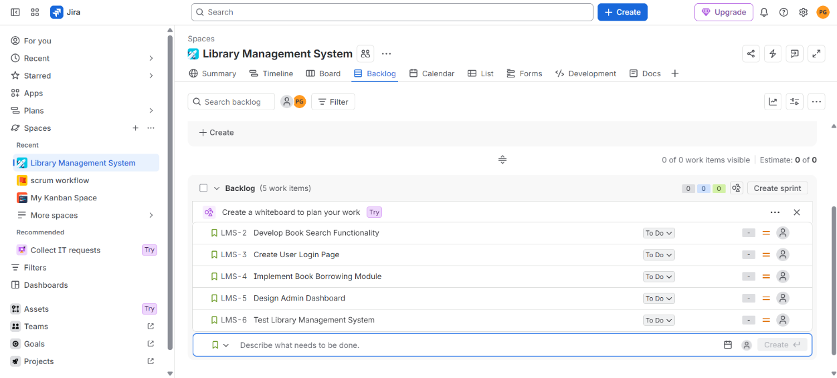
LINKING JIRA ISSUES WITH CONFLUENCE FOR PROGRESS TRACKING
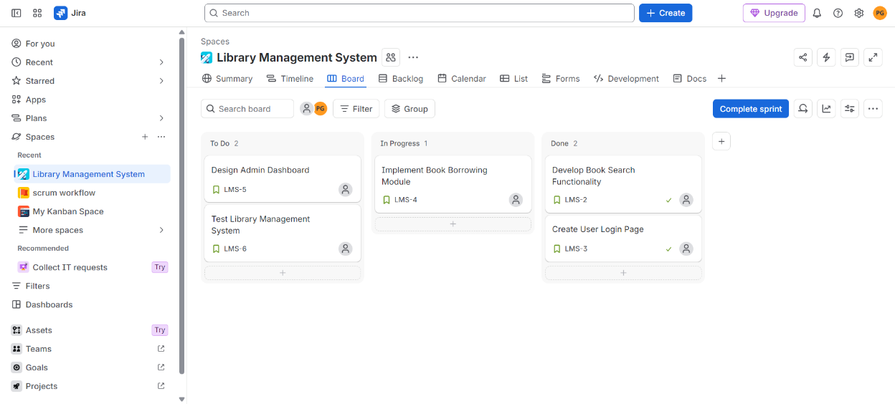

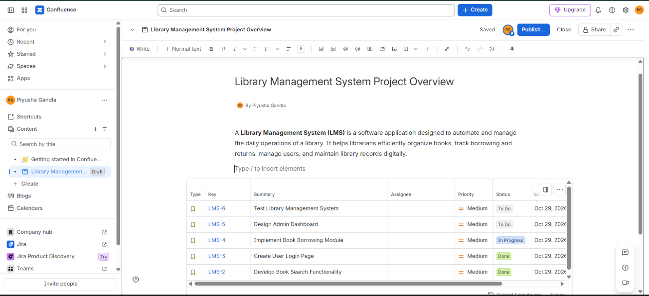

EXPERIMENT 7
PRIORITIZING TASK MANAGEMENT SYSTEM REQUIREMENTS USING MOSCOW AND KANO IN JIRA
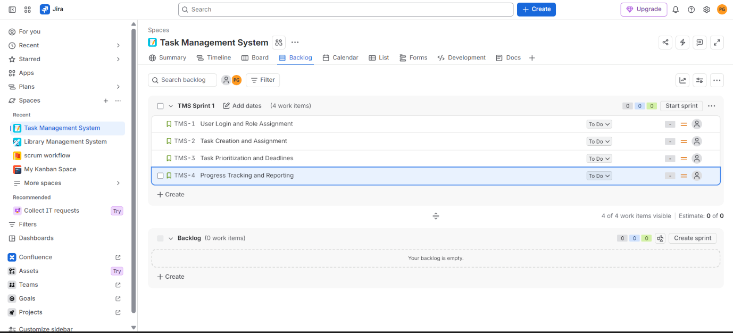
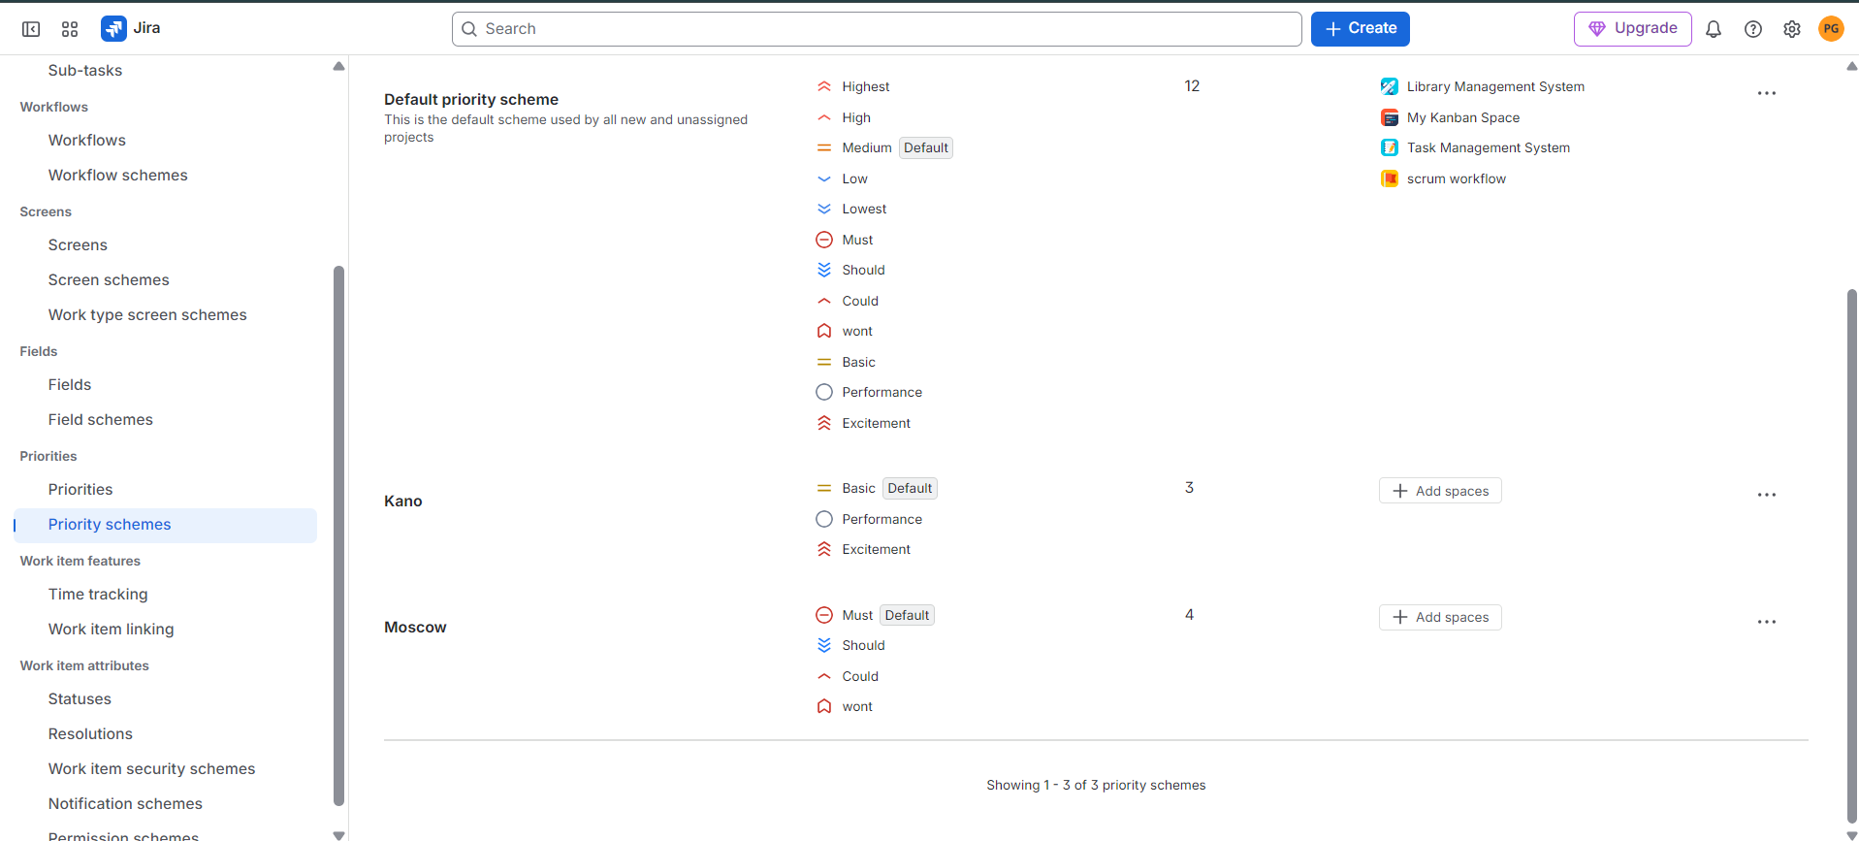
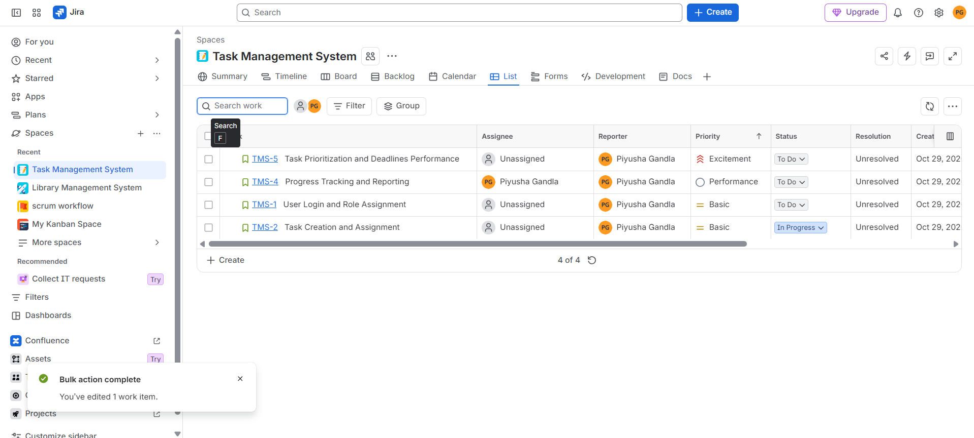

EXPERIMENT 8
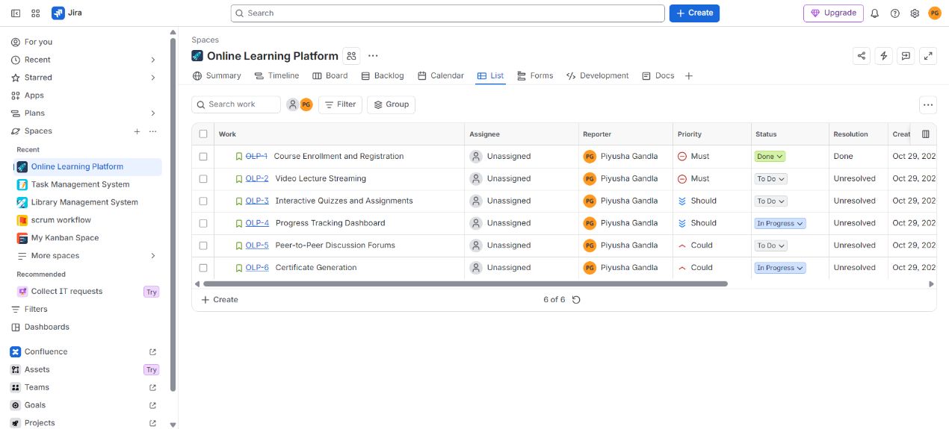
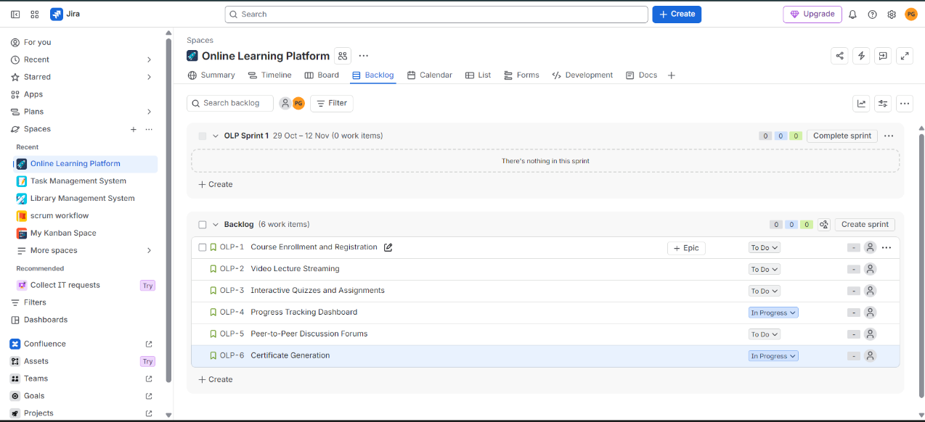
PRIORITIZING ONLINE LEARNING PLATFORM REQUIREMENTS USING MOSCOW AND KANO IN JIRA
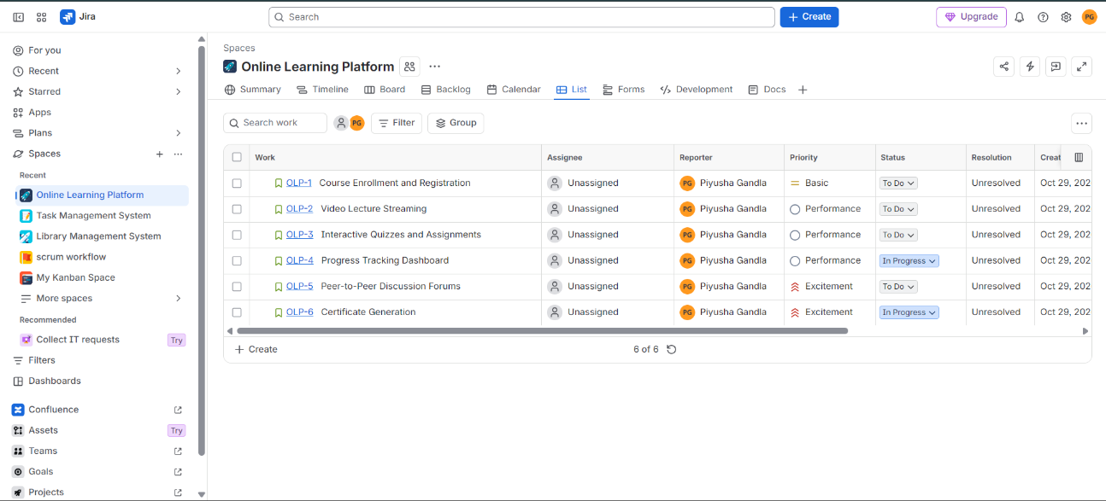

EXPERIMENT 9
FORK-AND-PULL-REQUEST COLLABORATION WORKFLOW USING GIT AND GITHUB
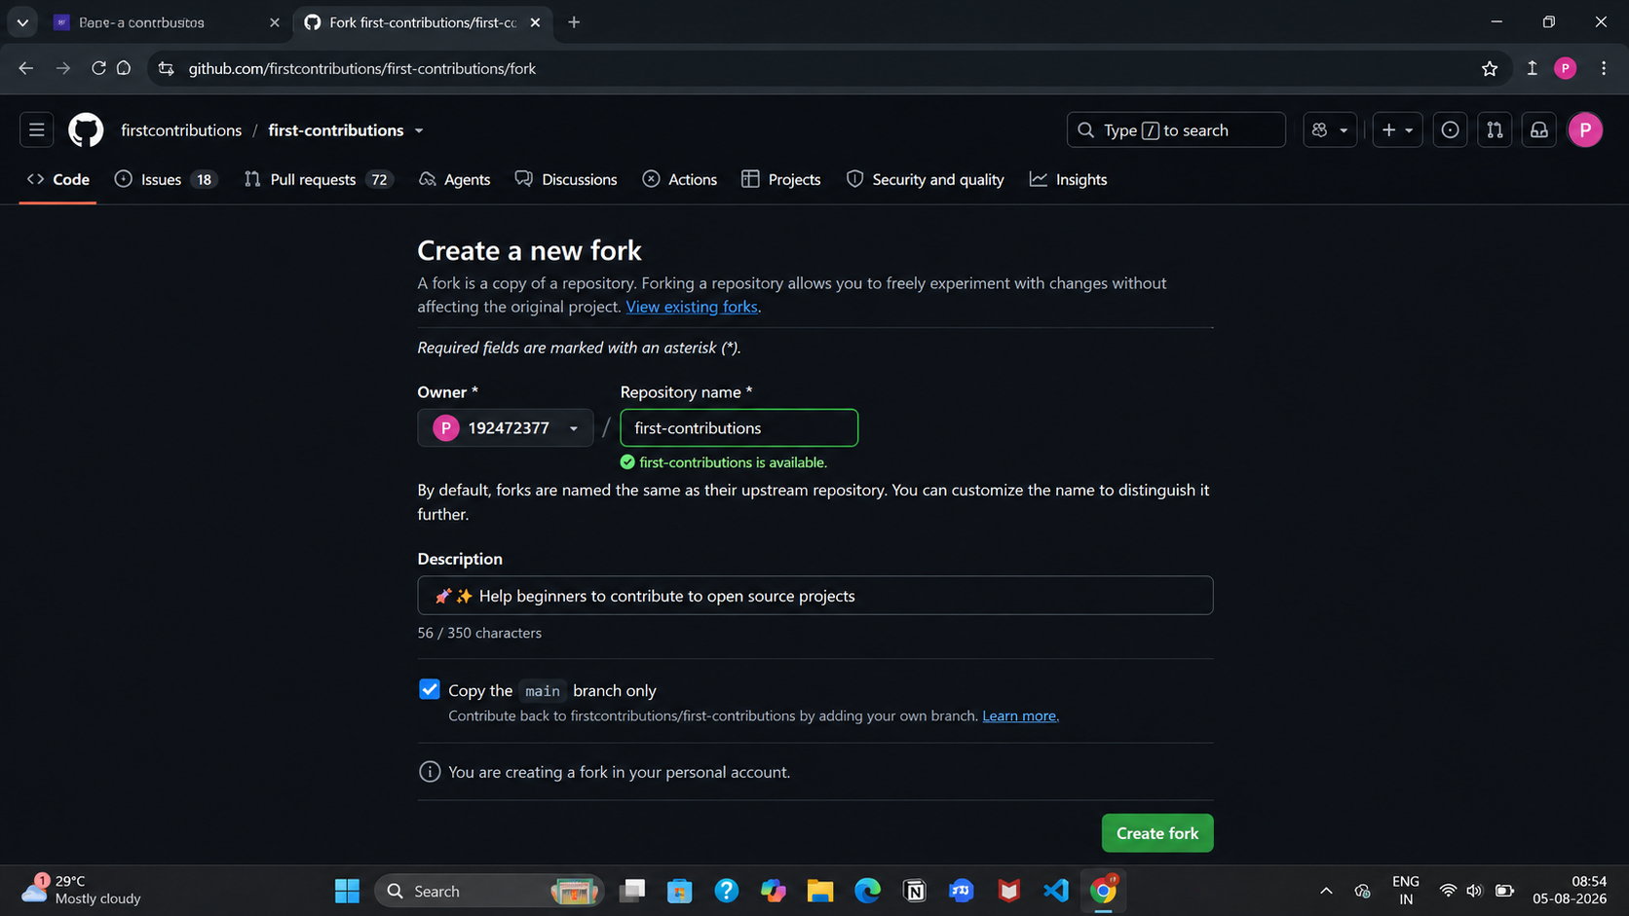

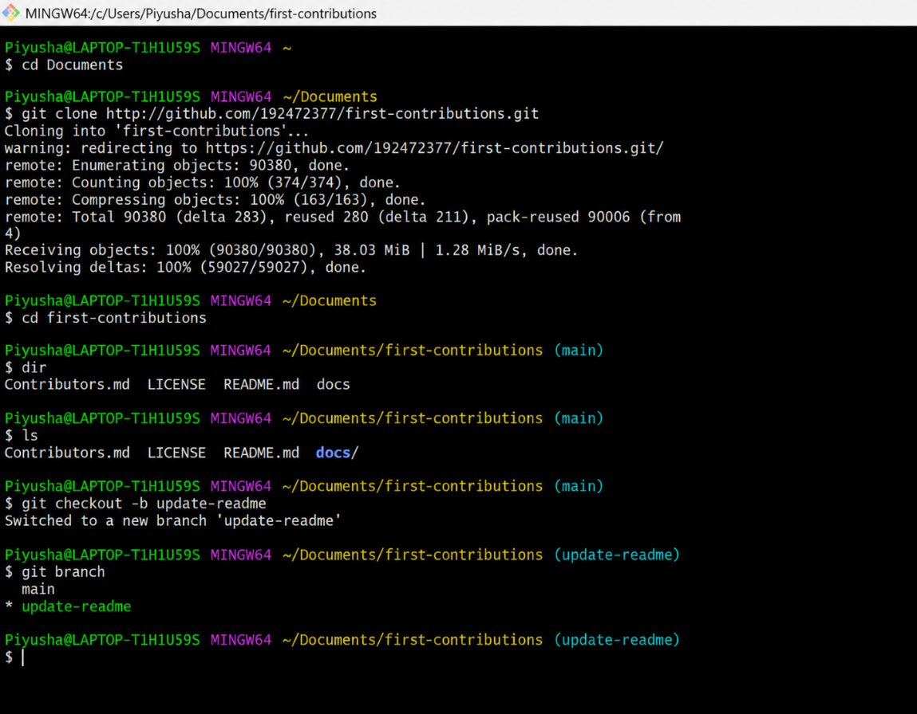

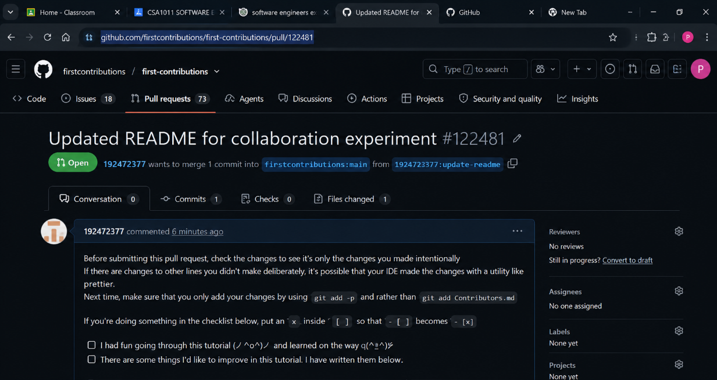
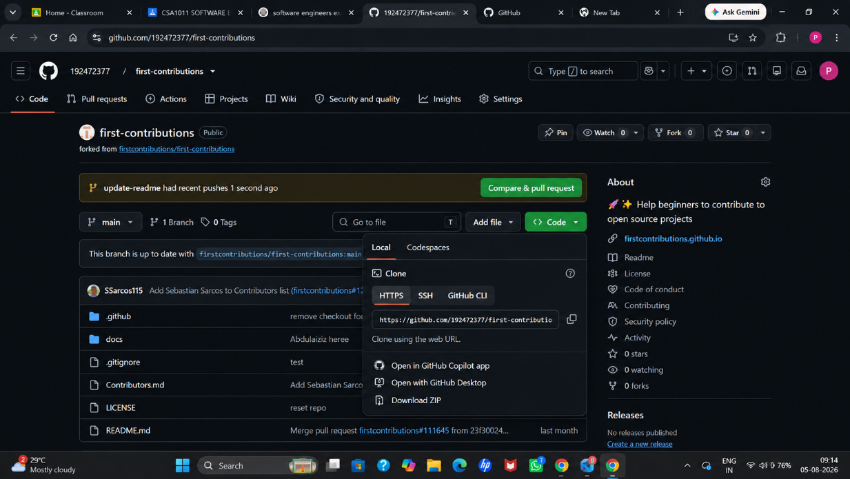

EXPERIMENT 10
WORKING WITH GIT BRANCHES AND RESOLVING MERGE CONFLICTS
